CLC - Assignment 1: Producer and Consumer

CST-315 Operating Systems

Nathan Dilla, Angel Velazquez

January 28, 2023

**Names, Roles, and Tasks Completed by Each Member**

*Nathan Dilla* **-** Wrote documentation for the CLC, wrote code

*Angel* **-** Wrote documentation for the CLC, wrote code

**Implementation**

Explanation of approach of implementation and reasoning

This is a computer-based solution to meet a given set of computing requirements. This program demonstrates the utilization and management of processes and threads. There are two processes: Producer and Consumer. The Producer process creates numbers passed to the Consumer process via a static buffer. Functions, get() and put() will use the buffer to ensure that the Consumer is not waiting for the Producer to make more numbers and that the Producer process maintains ahead of the Consumer process. As per requirement, this program does not use semaphores or other synchronization mechanisms but relies on threads via the pthread header file and sleep/wakeup commands.

**Screenshots**

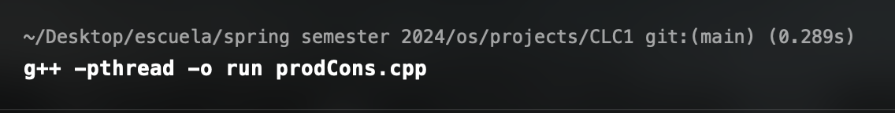

**Successful compilation of file**

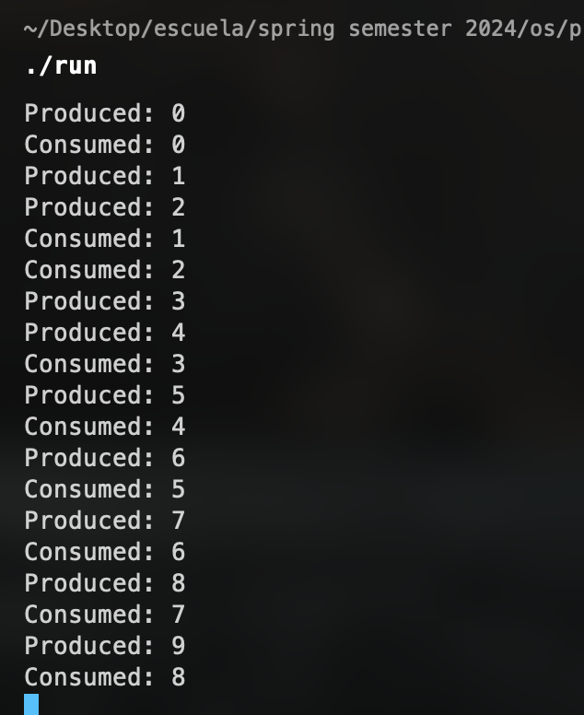

**Successful execution of file**

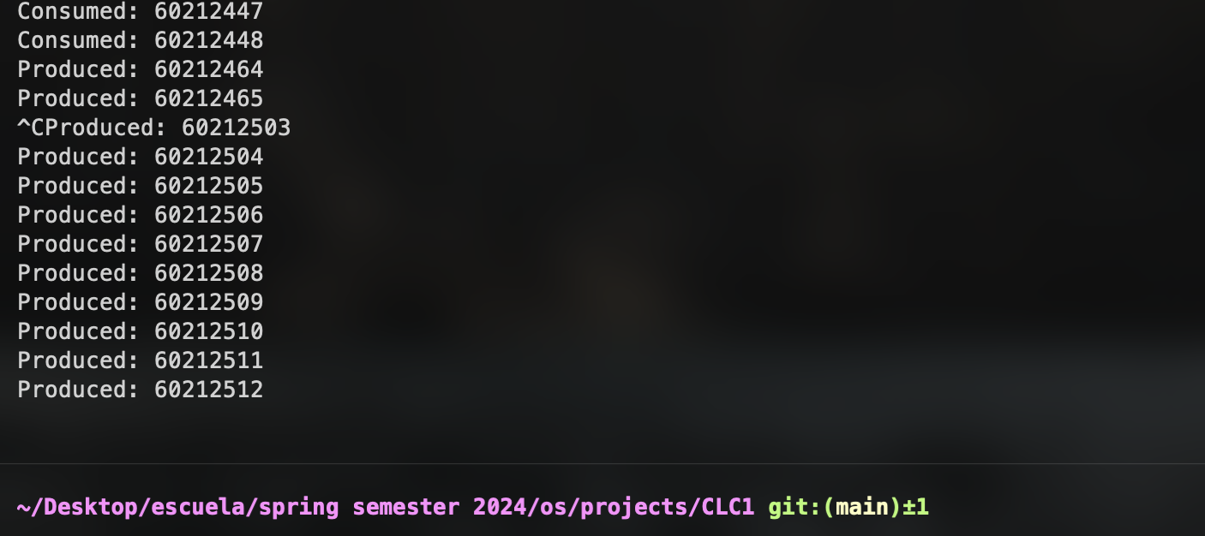

**Removed sleep calls to show that the program runs continuously visually**

**Repository Link:**

https://github.com/angel-vlzqz/Operating-Systems/tree/main/projects/CLC1